Application & Deployment

1. Open the following github repository <https://github.com/ZeroToHero-2017/JavaDocs/tree/master/Servlets/Day1> and copy the content to your forked github repository.
2. Go to the file location where you have copied the sources and open the project from the Code/servlet-app folder.
3. Complete TODO lines inside HelloWorldServlet.java file.
4. Complete TODO lines inside web.xml file.
5. Run maven clean install
6. Run maven tomcat7:deploy-only under the tomcat plugin

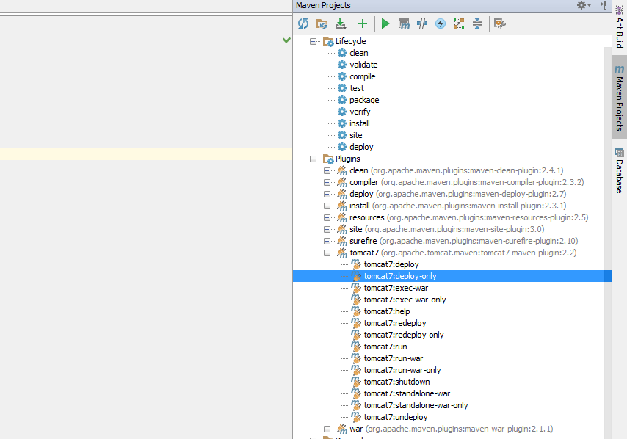

1. If you use tomcat locally, run tomcat7-run under tomcat7 plugin.

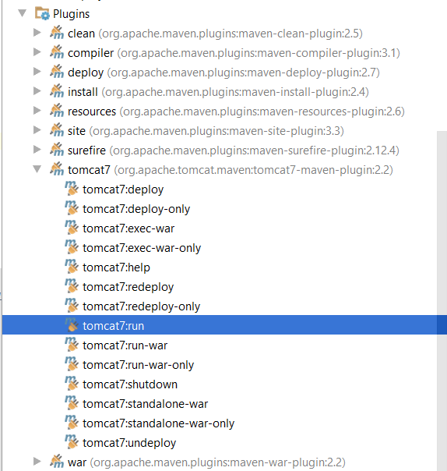

1. Open browser and insert <http://docker.local:49100/servlet-app/> URL or <http://localhost:8080/servlet-app> if you use local tomcat.

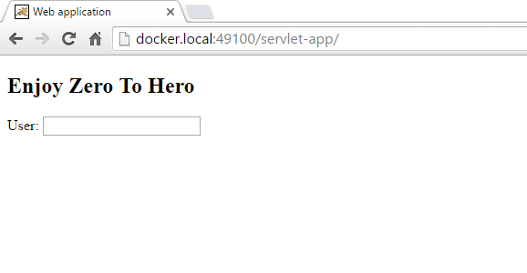

1. Insert some text into “User” input press enter and wait for server response

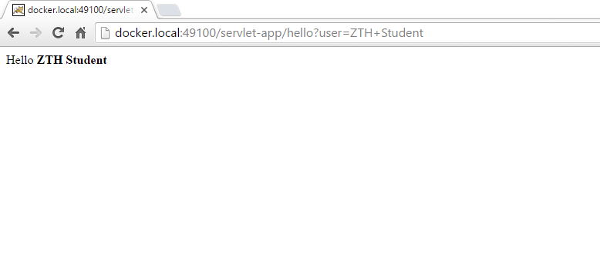

1. To update the web application deployed on the Docker tomcat container follow these steps:
   1. Change the line “<h2>Enjoy Zero To Hero</h2>” from the index.html to

<h2>I am enjoying zero to hero</h2>

* 1. Run mvn clean install
  2. Run maven tomcat7:undeploy under the tomcat plugin
  3. Run maven tomcat7:deploy-only under the tomcat plugin
  4. Check to see if the web page has updated

